The 2026 Northeast Oklahoma Regional Leadership Academy
NORA serves a 15-county rural region including: Adair, Cherokee, Craig, Delaware, McIntosh, Muskogee, Nowata, Okmulgee, Osage, Ottawa, Mayes, Rogers, Sequoyah, Washington, and Wagoner counties.

The Northeast Oklahoma Regional Leadership Academy Program
Today’s regional challenges require a new problem-solving capacity and the ability to work across political, geographical and institutional boundaries.

Through the NORA Leadership Academy, participants develop a broader awareness of the region. They acquire a greater knowledge of the interdependence of the diverse communities that constitute Northeastern Oklahoma. Additionally, participants sharpen leadership skills while networking with decision makers and professionals statewide.

The NORA Leadership Academy helps individuals build their personal, professional, and community leadership skills. Participants gain insight into the challenges facing Northeast Oklahoma and its 15 rural counties, develop effective leadership skills, and create a network to drive positive change in the region.

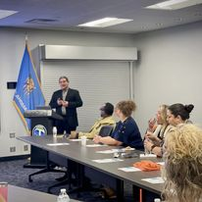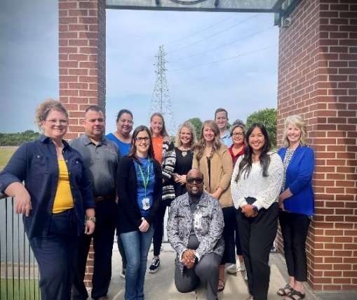

Join the NORA Leadership Academy and embark on a transformative 10-month program designed to develop your leadership skills, expand your professional network, and deepen your understanding of regional dynamics.

Program Highlights
Leadership Development: Gain valuable insights and practical skills through interactive workshops and expert-led sessions tailored to enhance your leadership capabilities.

NORA Legislative Reception: Engage with policymakers and influential leaders at our exclusive reception, gaining a unique perspective on regional and legislative issues.

NORA Summit Participation: Contribute to and learn from high-impact discussions at the NORA Summit, a key event for regional growth and development.

Regional Exploration: Explore different areas of the region each month, experiencing firsthand the diverse communities and industries that drive our area's growth.

Professional Networking: Connect with fellow regional professionals, fostering relationships that can lead to future collaborations and career opportunities.

NORA Membership: Graduates who complete the entire leadership program will receive a one-year membership to NORA, offering continued access to resources, events, and networking opportunities.

Enhance your leadership skills, broaden your professional connections, and gain a deeper understanding of our region through this comprehensive and engaging program.

About NORA
Northeast Oklahoma Regional Alliance (NORA) is a 501c3 nonprofit representing 15 rural counties in Northeast Oklahoma. Within those 15 counties are small, rural cities and towns and more than 600,000 individuals which is a similar population to both the OKC and Tulsa regions. NORA’s focus is completely on the rural sector. NORA is the unique organization dedicated to giving northeast Oklahoma a united, regional voice.

NORA plays a pivotal role in fostering economic development by providing a platform for members to connect and engage in collaborative efforts. Our focus includes supporting businesses, promoting entrepreneurial growth, advocating for regional issues, and actively contributing to the development of a robust workforce.

In addition to these efforts, NORA is committed to promoting education and leadership development, ensuring a strong talent pipeline for the future. Our programs, projects, and events are collaborative endeavors aimed at building a resilient economy and enhancing the quality of life in northeast Oklahoma.

Tuition
- Tuition for each participant is $850.00.
- A $50 non-refundable application fee is required with all applications.
- Tuition must be paid by January 31, 2026.
- Limited scholarship request forms are also available contacting director@neokregion.org

Requirements and Application Process
- Participants are required to attend eight out of ten sessions to achieve graduation. Attendance will be monitored.
- Application deadline December 1, 2025. Return application by email with letters of recommendation to: director@neokregion.org.
- Please complete the form below with the appropriate signatures.
- Please also include a recommendation letter from both recommenders.
- Notification to applicants will be by December 15.

Kick Off Session
- The kick off session is January 14 at the Bunker at the District 3822 W 530, Pryor, OK 74361
Please return this form electronically and return your $50 application fee to the address below. Tuition and deposit may be paid electronically at: https://www.zeffy.com/en-US/ticketing/nora-regional-leadership-academy--2026
NORA
PO Box 945
Tahlequah, OK 74465

Attire
Unless otherwise indicated, attire for the academy will be smart casual or business casual. Some sessions will require more casual attire due to tours. Class members will be notified in advance if the dress code is subject to change.
NORA LEADERSHIP ACADEMY APPLICATION
CANDIDATE INFORMATION
Name: |  | Shirt Size:
Date of birth:Click or tap here to enter text. |  |  | Phone:
Current address:
City: | State: |  | ZIP Code:
EMPLOYER COMMITMENT
Employer:
Employer address: |  |  | How long?
Phone: | E-mail: |  | Fax:
City: | State: |  | ZIP Code:
Position: | Employer Signature:
FIRST RECOMMENDER
Name and Title:
Address: |  |  | Phone:
City: | State: |  | ZIP Code:
Email Address:
SECOND RECOMMENDER
Name:

Address: | City: |  | State:
Email: | Phone:
Signatures (Document must be signed)
Signature of applicant: |  |  | Date:
1st Recommender: |  |  | Date:
2nd Recommender: |  |  | Date:

Your selection to the Northeast Oklahoma Leadership Academy is based solely on the information contained in this application. Please limit your responses to no more than 150 words per response.

- Describe your involvement in community or regional initiatives. How have you contributed to your community or region? Include specific organizations you are involved in and your monthly commitment to each organization.

Click or tap here to enter text.

- What do you like best about living in Northeast Oklahoma? What do you like the least?

Click or tap here to enter text.

- Identify and briefly explain three challenges you feel exist in NORA’s region?

Click or tap here to enter text.

- How would you attempt to resolve the most critical challenge of those listed above?

Click or tap here to enter text.

- What is your primary motivation to participate in NORA’s Leadership Academy and how do you hope to apply what you learn in your community or organization?

Click or tap here to enter text.

- The program spans ten months with various commitments, including class days and events and potentially overnight commitments. Are you able to commit to the full duration of the program? Participants may not miss more than two sessions to be eligible for graduation.

Click or tap here to enter text.

